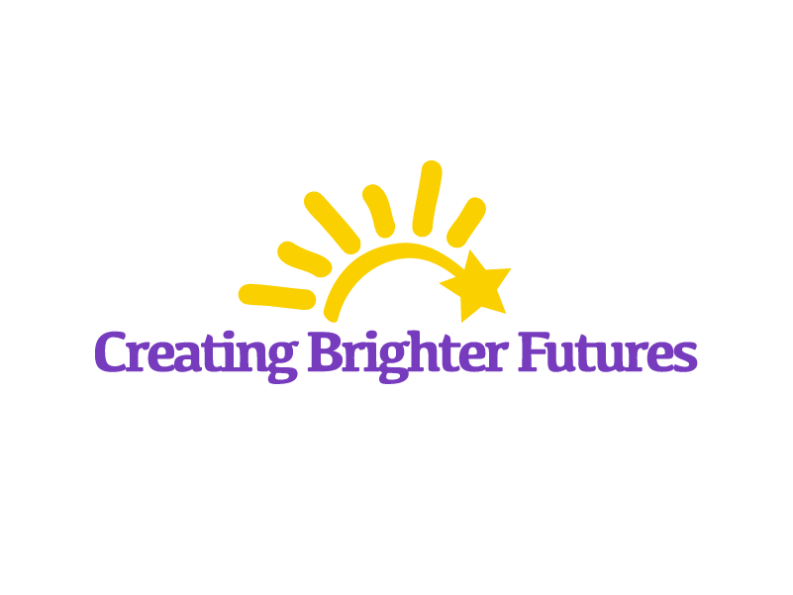
4201 Varsity Drive
Suite B & C
Ann Arbor, MI 48108
(P) 734-926-0740
(F) 734-369-8851

Translation Services Information

Creating Brighter Futures is readily open to providing services to people of all backgrounds, cultures, ethnicities, and languages. We understand that English is not every family’s first or preferred language, and we want to best assist those who are interested in our services with the resources they need. This document will provide resources (i.e. 3rd party or county resources) that can be obtained on behalf of the requester. Additional information pamphlets from the WHP can be given if requested by the family. All requests for the use of translation services will be accommodated by Creating Brighter Futures.

Washtenaw Health Project
The Washtenaw Health Project (formally the Washtenaw Health Plan) is an organization part of the Washtenaw County Health Department that aids in providing healthcare coverage for those who live and receive services in the county. In part, their team provides in-person translation services that can help you contact local clinics and offices. The languages they translate include:
- Spanish
- French
- Arabic
For over 200+ additional languages, WHP can connect themselves and you with an interpreter through a telephone translation service. This can be done for clients either in-person or over-the-phone. They have never been unable to accommodate a client because of language barriers.
For the best customer experience, WHP recommends clients visit them in-person if they are able for their first visit, and, if applicable, a follow-up visit can either be done in-person, over-the-phone, email, or text message.
Contact the WHP for more information regarding translation or with any questions regarding any of their additional services:
- 555 Towner Street, Ypsilanti, MI 48198
- (734) 544-3030
- whp@washtenaw.org
- https://washtenawhealthproject.org/

